Name: **Talha** | Roll no. **220989** | Programming fundamentals | Lab#4

---------------------------------------------------------------------------------------------

**Info: The below code ran on G++ compiler of version 12.2.0, text editor use for this purpose is sublime-text-editor**

**Problem#1:**

#include <iostream>

using namespace std;

int main()

{

int a{0};

cout << "Enter number to check whether it is greater than 50 or not: ";

cin >> a;

a > 50? cout << "greater": cout << "smaller";

return 0;}

**[Output]:**

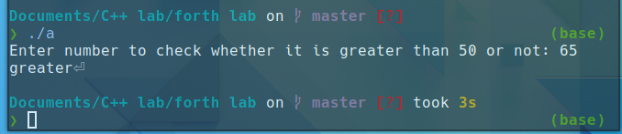

**Problem#2:**

#include <iostream>

using namespace std;

int main(){

int a{0};

cout << "Enter number to check whether it is greater than 50 or not: ";

cin >> a;

if (a > 50)

{

cout << "Entered number is greater than 50";

}

else

{

cout << "your Entered value is smaller";

}

return 0;

}

**[Output]:**

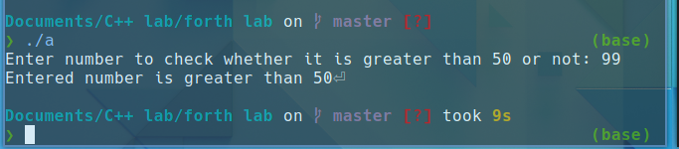

**Problem#3:**

#include <iostream>

using namespace std;

int main()

{

int val{0}; float bonus{0};

cout << "Enter balance: ";

cin >> val;

val > 5000? cout << "your new balance is: " << val + val * 0.01 : cout << "sorry you are not eligble";

return 0;

}

**[Output]:**

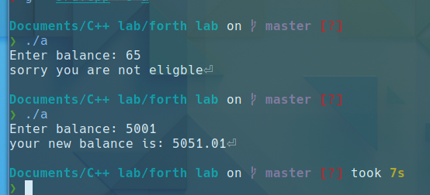

**Problem#4:**

#include <iostream>

using namespace std;

int main(){

int ini_bal{0}; float new_bal{0};

cout << "Enter your balance: ";

cin >> ini_bal;

if (ini_bal>5000){

new_bal = (0.1*ini_bal) + ini_bal;

cout << new_bal;

}

else{

cout << "\nsorry you are not eligble for bonus";

}

return 0;

}

**[Output]:**

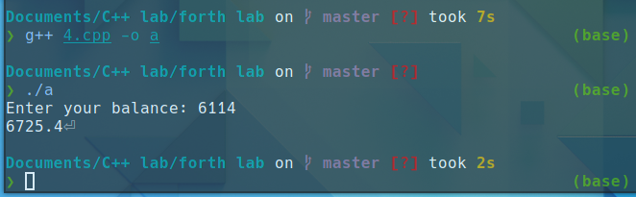

**Problem#5:**

#include <iostream>

using namespace std;

int main()

{

int a,b,c;

cout << "Enter first number: ";

cin >> a;

cout << "Enter second number: ";

cin >> b;

cout << "Enter third number: ";

cin >> c;

a>b&&a>c? cout << "greatest number is: "<<a : cout << endl;

b>a&&b>c? cout << "greatest number is: "<<b : cout << endl;

c>a&&c>b? cout << "Greatest number is: "<<c : cout << endl;

return 0;

}

**[Output]:**

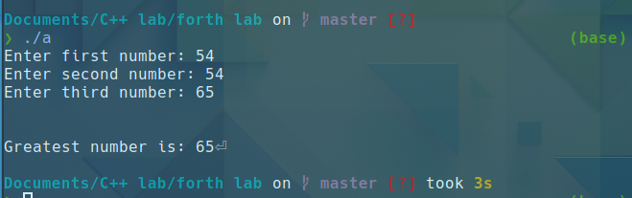

**Problem#6:**

#include <iostream>

using namespace std;

int main()

{

int val{0};

cout << "Enter number to check whether it is even or odd: ";

cin >> val;

if (val%2==0){

cout<< "Entered value is even";

}

else {

cout << "Entered value is odd";

}

return 0;

}

**[Output]:**

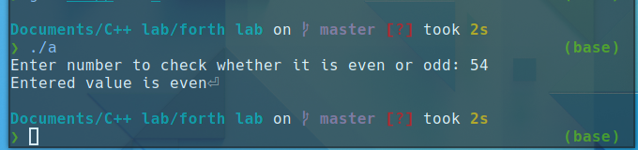

**Problem#7:**

#include <iostream>

using namespace std;

int main(){

int val{0}; float diff{0}, quo{0};

cout << "Enter a number to check whether it is even or odd: ";

cin >> val;

// int(7/2) - float(7/2)

diff = int(val/2) - float(val/2.0);

if (diff !=0){

cout << "Entered number is odd";

}

if(diff ==0) {

cout << "Entered number is even";

}

return 0;

}

**[Output]:**

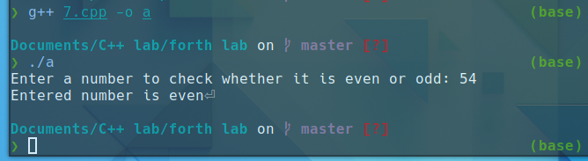

**Problem#8:**

#include <iostream>

using namespace std;

int main(){

int mil{0};

cout << "Enter milage of car in per gallon fuel: ";

cin >> mil;

mil >=40? cout << "your car got good milage": cout << "your car got poor milage";

return 0;

}

**[Output]:**

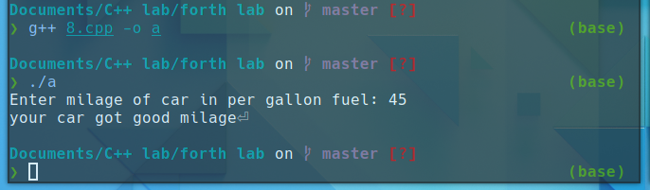

**Problem#9:**

#include <iostream>

using namespace std;

int main(){

int mil{0};

cout << "Enter milage of car in per gallon fuel: ";

cin >> mil;

if (mil>=40)

{

cout << "Your car got good milage";

}

else {

cout << "Your car got poor milage";

}

return 0;

}

**[Output]:**

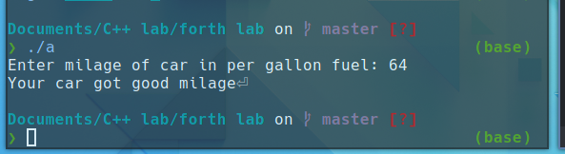

**Problem#10:**

#include <iostream>

using namespace std;

int main(){

int num1{0}, num2{0},div{0},quo{0};

cout << "Enter two numbers"<< endl;

cout << "Enter first number: ";

cin >> num1;

cout << "Enter second number: ";

cin >> num2;

div = num1 % num2;

if (div ==0)

{

cout << num1 <<" is completely divisible by " << num2;

float quo = num1/num2;

cout << "and the quotient is: " <<quo<<endl;

}

else

{

cout << num1 <<" is not completely divisible by " << num2 <<endl;

float quo = num1/num2;

cout << " and the quotient is: " <<quo << " and remainder is " <<quo <<endl;

}

return 0;

}

**[Output]:**

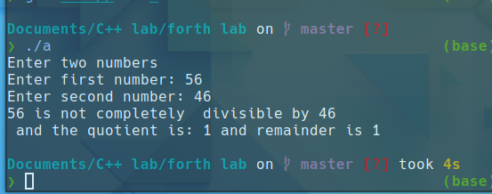

**Problem#11:**

// Lets say that the letter grade of a student is calculated based on the following percentage table:

// Take the value of Percentage as input from the user. Based on the Percentage, print the grade of the

// student and relevant message. Also, if the Percentage is greater than 100 or less than 0, print

// “Percentage is out of range”.

#include <iostream>

using namespace std;

int main(){

float std_per{0}; char grade;

cout << "Enter your obtained percentage: ";

cin >> std_per;

//80 < percentage<=100

if((std_per<=100) && (std_per>80))

{

grade = 'A';

cout << "\nCheetah Bacha \nGrade: "<<grade;

}

// 70 < percentage <= 80

else if ((std_per>70) && (std_per <=80))

{

grade = 'A';

cout << "\nAcha Bacha \nGrade: " <<grade<< "-" ;

}

//60 < percentage <= 70 B+ Theek Bacha

else if((std_per>60) && (std_per<=70))

{

grade = 'B';

cout << "\nTheek Bacha \nGrade: "<<grade<< "+";

}

//50< percentage <= 60 B Guzara Bacha

else if((std_per>50)&&(std_per<=60))

{

grade = 'B';

cout << "Guzara Bacha \nGrade: "<<grade;

}

//40< percentage <= 50 B- Matha Bacha

else if((std_per>40) && (std_per <=50))

{

grade = 'B';

cout << "\nMatha Bacha \nGrade: "<<grade<< "-";

}

//33 < percentage <= 40 C+ Farig Bacha

else if((std_per>33)&&(std_per<=40))

{

grade = 'C';

cout << "\nFarig Bacha \nGrade: "<<grade<< "+";

}

//percentage <= 33 F Koi Haal Nahin

else if((std_per>0)&&(std_per<=33))

{

grade = 'F';

cout << "\nkoi Haal nahi \nGrade: "<<grade;

}

else

{

cout << "\nEnter correct percentage";

}

return 0;

}

**[Output]:**

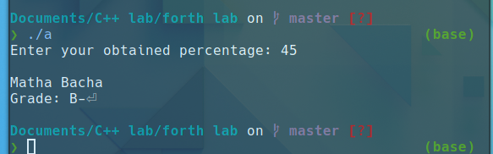

**Problem#12:**

#include<iostream>

using namespace std;

int main()

{

int r,h=0; float vol;

cout << "Enter radius: ";

cin >> r;

cout << "Enter value of height: ";

cin >> h;

vol = 1/3.0 * (3.14*r*r*h);

if ((vol>=100)&&(r%2==0))

{

cout << "Acha Cone";

}

else

{

cout << "Ganda Cone";

}

return 0;

}

**[Output]:**

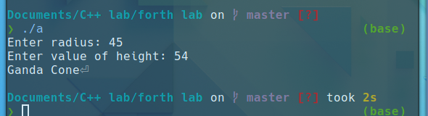

**Problem#13:**

#include <iostream>

using namespace std;

int main(){

int a{0},b{0};

cout << "Enter number to check whether it is even or odd \n";

cout << "Enter first number: ";

cin >> a;

cout << "Enter second number: ";

cin >> b;

if ((a%2==0)&&(b%2==0)){

cout << "Both are even numbers";

}

else if ((a%2!=0)&&(b%2!=0)){

cout << "Both are odd numbers";

}

else if ((a%2!=0)||(b%2!=0)){

cout << "one is even and other one is odd";

}

return 0;

}

**[Output]:**

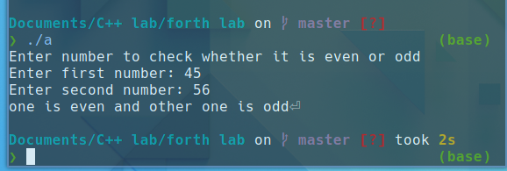

**Problem#14:**

#include <iostream>

using namespace std;

int main()

{

int val;

cout << "Enter a number between 1-100: ";

cin >> val;

if ((val<=100)&&(val>=1))

{

if(val>50)

cout << "\nyour entered value is greater than 50";

else

cout << "\nyour Entered value is less than 50";

}

else

cout << "\nPlease Enter value between 1-100";

return 0;

}

**[Output]:**

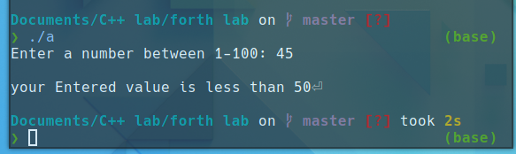

**Problem#15:**

#include <iostream>

using namespace std;

int main()

{

int db;

cout << "Enter noise level: ";

cin >> db;

if ((db>0)&&(db<=50))

cout<<"lower quite";

else if ((db>=51)&&(db<=70))

cout << "intrusive";

else if ((db >=71)&&(db<=90))

cout << "annoying";

else if ((db >=91)&&(db<=110))

cout << "very annoying";

else if (db>=110)

cout << "unconfortable";

return 0;

}

**[Output]:**

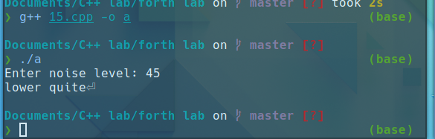

**Problem#16:**

#include <iostream>

using namespace std;

int main()

{

int val;

cout << "Enter a number between 1-100: ";

cin >> val;

if((val>50))

{

if (val%5==0)

cout << "Number is greater than 50 and is a multiple of 5";

else

cout<< "Number is greater than 50 and is a multiple of 5";

}

else if (val<50)

{

if (val%5==0)

cout << "Number is less than 50 and multiple of 5";

else

cout << "Number is less than 50 and multiple of 5";

}

else

cout << "\nPlease Enter correct number";

return 0;

}

**[Output]:**

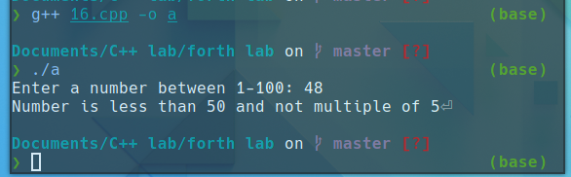

**Problem#17:**

#include<iostream>

using namespace std;

int main ()

{

char x{'0'},y{'0'};

cout<<"Enter the temperature, 'W' for warm and 'C' for cold : ";

cin>>x;

cout<<"Enter the Humidity, 'D' for dry and 'H' for Humid : ";

cin>>y;

if(x=='W'&&y=='D')

cout<<"Play tennis. ";

else if(x=='W'&&y=='H')

cout<<"Swim. ";

else if(x=='C'&&y=='D')

cout<<"Play basketball. ";

else

cout<<"Watch Tv. ";

return 0;

}

**[Output]:**

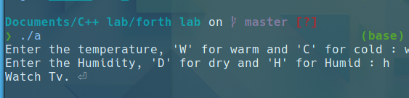

**Problem#18:**

#include <iostream>

using namespace std;

int main()

{

float bat_avg{0}, bowl_avg{0}, bat_str{0}, eco_rate{0};

char bowl_type{'0'};

cout << "Enter batting and bowling average: ";

cin >> bat_avg >> bowl_avg;

cout << "Enter strike rate and economy rate: ";

cin >> bat_str >> eco_rate;

cout << "Enter type of bowler (s for spin and f for fast): ";

cin >> bowl_type;

if (bat_avg >= 45 && bowl_avg >= 60)

{

cout << "You are batsman" << endl;

if (bat_avg >= 50 && bat_str <= 70)

{

cout << "You are test batsman" << endl;

}

else

cout << "You are odi batsman" << endl;

}

else if (bowl_avg <= 30 && bat_avg <= 20)

{

cout << "You are bowler" << endl;

if (bowl_type == 115)

{

if (bowl_avg > 20 && bowl_avg <= 30)

{

if (eco_rate <= 3)

{

cout << "You should play in test side" << endl;

}

else

cout << "You should play in odi" << endl;

}

}

if (bowl_type == 102)

{

if (bowl_avg > 20 && bowl_avg <= 30)

{

if (eco_rate <= 5 && eco_rate >= 3)

{

cout << "You should play in odi" << endl;

}

else

{

cout << "You should play test" << endl;

}

}

}

}

else if (bat_avg >= 40 && bowl_avg <= 30)

{

cout << "You are all rounder" << endl;

if (bat_avg >= 40 && bowl_avg <= 25)

{

cout << "You are test player" << endl;

}

else

cout << "You are odi player" << endl;

}

else

cout << "You are reserved player"<<endl;

return 0;

}

**[Output]:**

